Requirements/Design Specification

**July2015 GH571**

**Existing customer Renewal Term bug (CR 14073)**

Revision History

|  |  |  |  |
| --- | --- | --- | --- |
| **Date** | **Revision** | **Description** | **Author** |
| 5/18/2015 | 1.0 | Initial Version with Requirements | Gaurav Dawar |
|  |  |  |  |
|  |  |  |  |
|  |  |  |  |
|  |  |  |  |

The information furnished herein by Republic Services Inc. is proprietary and confidential to Republic Services Inc. personnel and is not to be duplicated, published, or disclosed to any third party in whole or in part without permission from Republic Services, Inc.

© Copyright 2012, Republic Services Inc. - All rights reserved.

Table of contents

1 Business Requirements 6

1.1 Purpose of the Design Specification 6

1.1.1 Bug list for current release 6

2 Competitor Overview and Assumptions 6

3 Design 6

4 Impacted Systems (InfoPro, TIBCO and BI) 8

5 Report Changes 8

6 Appendix 8

# Business Requirements

## Purpose of the Design Specification

This document highlights items to be fixed and implemented for the titled release.

### Bug list for current release

| GitHub Item  Number | **Description** |
| --- | --- |
| 571 | Existing customer Renewal Term bug (CR 14073) |

# Overview and Assumptions

Since there is a rule created recently for few “A03” divisions to constrain all the values for renewal terms except “MTM” (Cosntrain for NJ Divisions). Which is conflicting with another function only for one division 4323. The other function is “Setting Defaults for Initial and Renewal terms based on lawson division”, So for division 4323 the default is “36” months which is constrained by the above mentioned constrain rule.

# Design

## #571 Existing customer Renewal Term bug (CR 14073)

Division 4323 is to be removed from the constrain rule “Cosntrain for NJ Divisions”, Since default renewal term for 4323 in “Div_Terms_Exceptions” table is “36 Months”.

No new variables will be created.

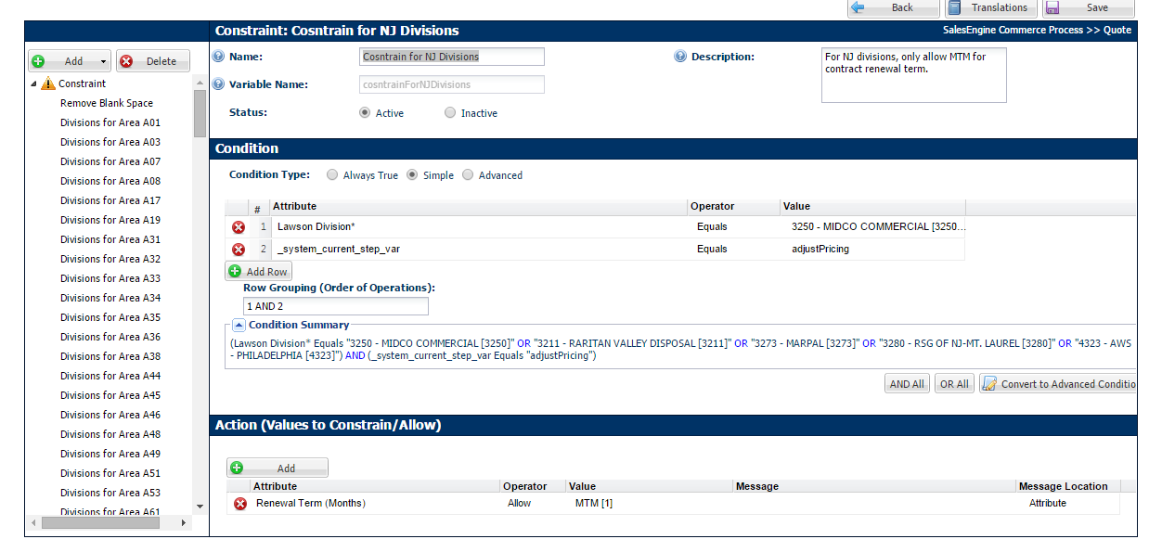

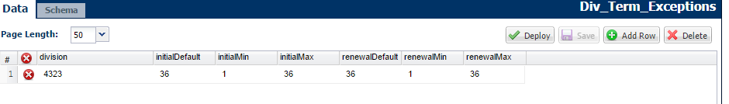

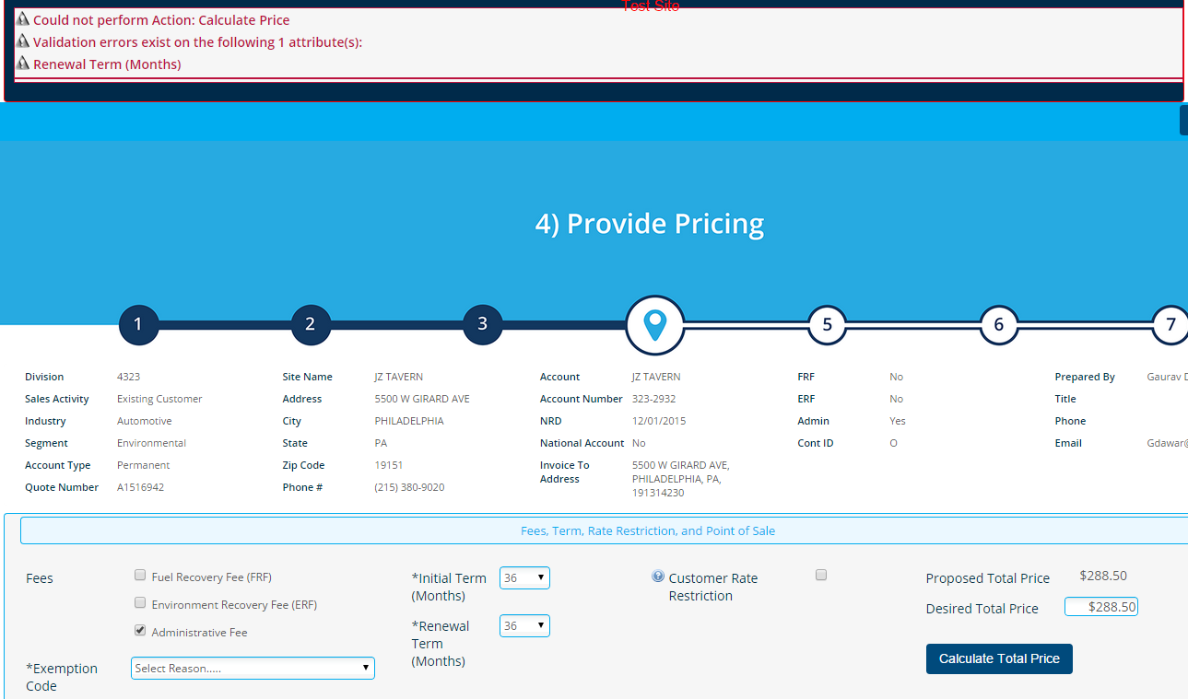

# Impacted Systems (InfoPro, TIBCO and BI)

No new variables were created hence this fix should not affect InfoPro AAE process.

# Report Changes

NA

# Appendix